1) Query the list of CITY names from **STATION** that do not start with vowels. Your result cannot contain duplicates.

Solution-Select distinct city from station where (city not like 'A%' and city not like 'E%' and city not like 'I%' and city not like 'O%' and city not like 'U%') ;

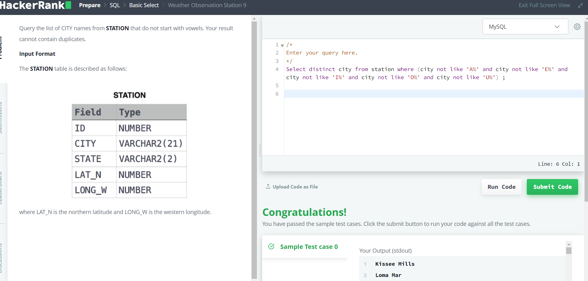

2) Query the list of CITY names from **STATION** that do not end with vowels. Your result cannot contain duplicates.

Solution-

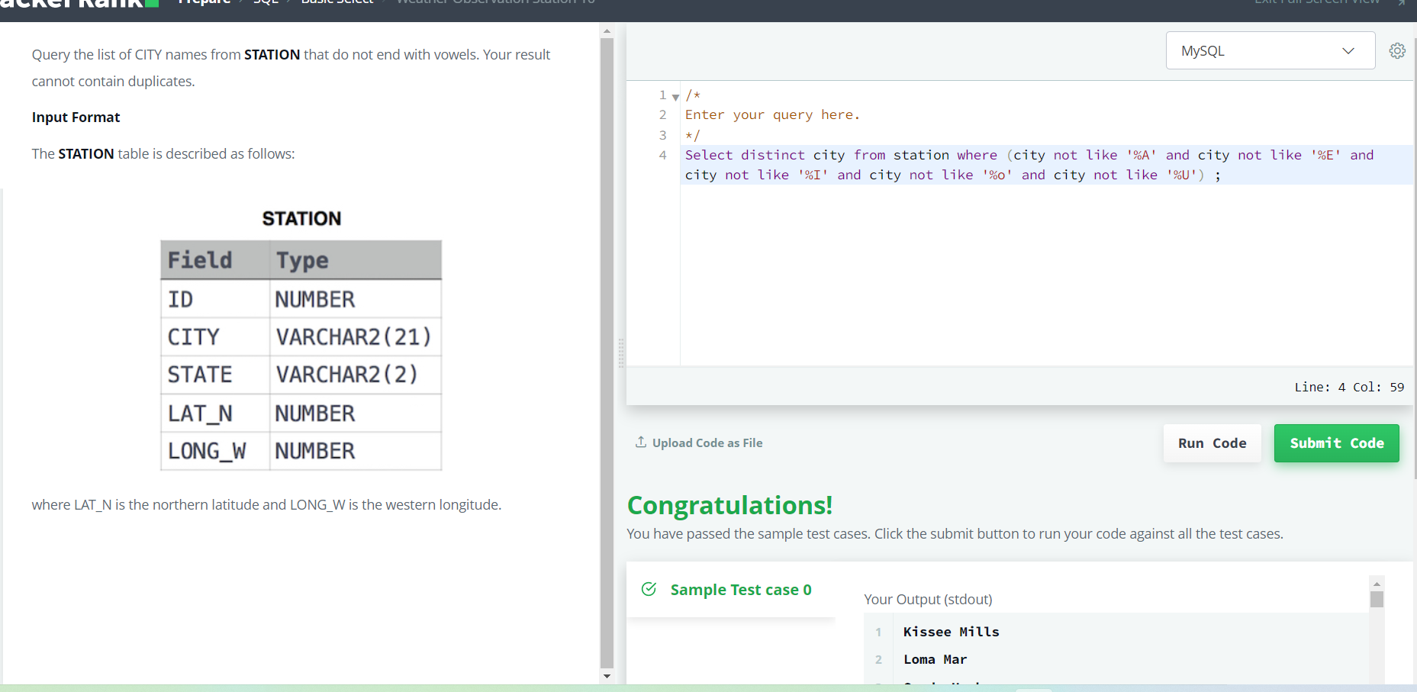

3) Query the list of CITY names from **STATION** that either do not start with vowels or do not end with vowels. Your result cannot contain duplicates.

Solution- select distinct CITY from STATION where left(CITY,1) NOT in('a','e','i','o','u') or right(CITY,1) NOT in('a','e','i','o','u')

4) Query the Name of any student in **STUDENTS** who scored higher than  Marks. Order your output by the last three characters of each name. If two or more students both have names ending in the same last three characters (i.e.: Bobby, Robby, etc.), secondary sort them by ascending ID.

Solution- select name

from students

where marks > 75

order by right(name,3), id asc;

5) Write a query that prints a list of employee names (i.e.: the name attribute) from the **Employee** table in alphabetical order

6) Write a query that prints a list of employee names (i.e.: the name attribute) for employees in **Employee** having a salary greater than  per month who have been employees for less than  months. Sort your result by ascending employee_id.

Solution- select name from employee where salary>2000 and months<10 order by employee_id asc;

